‘Approved provider’ and Regulatory Authority [2017] ACECQARRPstr0026 (26 April 2017)

Date of Decision: 26 April 2017
Application reference: STR0026

Decision:
The Ratings Review Panel (the panel) by consensus decided to confirm the rating for the service is Significant Improvement Required.

Issues under review
- The approved provider sought a review of ratings on the grounds that the regulatory authority failed to take into account or give sufficient weight to special circumstances or facts existing at the time of the rating assessment.

- After the service’s assessment, the service was rated Significant Improvement Required (SIR). At first tier review, the regulatory authority confirmed the rating. The provider submitted the service should be rated Working Towards.

- The provider submitted that a number of aspects referred to by the regulatory authority were fixed between the first and second days of the assessment and rating visit but that the regulatory authority did not give consideration to the fact that these aspects were resolved.

Evidence before the panel
- The panel considered all the evidence submitted by the provider and the regulatory authority.

- The Panel was also provided with advice from ACECQA on the rating levels.
The law
- Section 151 of the National Law states that following a review, the Ratings Review Panel may:
(a) confirm the rating levels determined by the Regulatory Authority; or
(b) amend the rating levels.

Significant Improvement Required Ratings
- The panel considered the following information about the SIR rating taken from the Operational Policy Manual for Regulatory Authorities (OPM) which is published on ACECQA’s website.

- In some cases where an element is not met, this may relate to non-compliance with the National Law and/or National Regulations. The identified compliance issues may be reflected in the assessment and rating report, and compliance action may be taken in parallel to the assessment and rating process.

- ‘Unacceptable risk to the safety, health or wellbeing of any child or children being educated and cared for by the service’ is not defined in the National Law and Regulations, although it is used as grounds for a range of compliance actions, including cancelling a service approval.

- Regulatory authorities should reassess services which have been rated SIR as soon as practicable. The reassessment is an opportunity to check the service is meeting minimum requirements to ensure the health, safety and wellbeing of children in attendance.

- The SIR rating is a public rating and therefore indicates to families that a service is failing to meet the Regulations in a way that poses an unacceptable risk to the health, wellbeing or safety of children. It is intended to motivate a provider that receives the rating to address the failure(s) and ultimately ensure that children at the service are not exposed to unacceptable risks.

- An unacceptable risk is more likely to arise when there is non-compliance with the physical environment, children’s health and safety, or staffing requirements, but it could arise in other parts of the NQS. For example, very poor practice in Quality Area 1 – Educational Program and Practice could pose a significant risk to the wellbeing of a child or children given the critical role of Quality Area 1 in promoting children’s brain development.

Analysing risk
- The National Law and Regulations do not define ‘risk’. A common tool used to analyse the level of risk is a risk matrix (see below).

- This tool helps identify the level of risk by looking at how likely it is a negative event may occur, and the severity of the consequence should it occur.

- Risk can arise through any part of the environment where education and care is provided to children. This includes the physical environment, staff members and other people at the service. Risk can arise from an action or through a failure to act. Risks can also emerge from systemic failure, such as a provider not having adequate systems in place to control for risk.

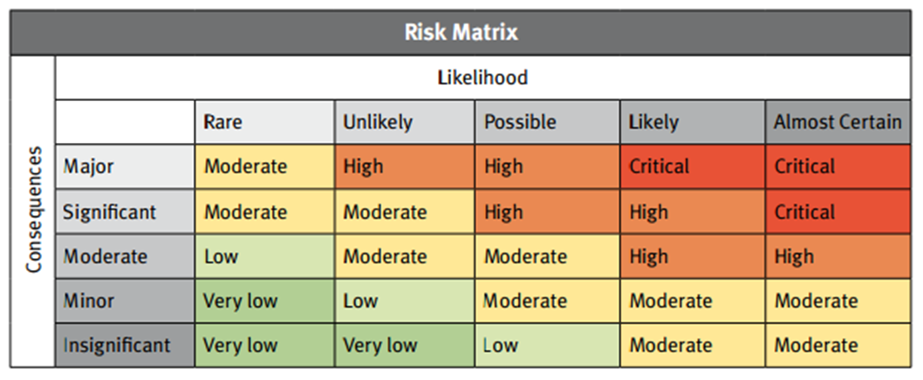

- The risk matrix includes five levels of likelihood, which are described below. When thinking about likelihood, regulatory authorities should take into account factors such as history of compliance, as well as readiness, willingness and ability to comply. It is also important to consider how soon an event might occur, as this will help decide the most suitable action for responding to the risk.

Likelihood | Description
Rare | Very unlikely – the event may occur only in exceptional circumstances
Unlikely | Improbable – the event is not likely to occur in normal circumstances
Possible | Potential – the event could occur at some time
Likely | Probable – the event will probably occur in most circumstances
Almost certain | Very likely – the event is expected to occur in most circumstances

- The risk matrix includes five levels of consequence: insignificant, minor, moderate, significant and major. This takes into account the impact, or potential impact, of an event including its scale and duration. A consequence might affect the safety and wellbeing of children at the service, their family or the wider community.

- When analysing the consequences of a potential event, regulatory authorities should consider the vulnerability of people who might be affected. For instance very young children or children with a disability may be particularly vulnerable, because they are less able to act to protect their wellbeing.

- Harm to children might arise as the result of a single incident or from several incidents that occur over time. This is known as cumulative harm.

- The National Law allows regulatory authorities to prevent a provider or service from operating if the regulatory authority is satisfied there is an unacceptable risk to the health, safety or wellbeing of children at the service. In the case of a prohibition notice, the regulatory authority can prevent a person from having any involvement with any service if they are satisfied there is an unacceptable risk.

- The regulatory authority may consider there is an unacceptable risk if the operation of the service has resulted in harm to children, and the regulatory authority considers that there are no options for effectively reducing the risk to children. For example, the regulatory authority may have made previous attempts to ensure the provider reduces or eliminates risk to children, without success.

- Because risk includes analysing potential consequences, the regulatory authority might also be satisfied there is an unacceptable risk to children even where no child has been harmed.

- Regulatory authorities can use the risk matrix to help determine whether a risk is unacceptable. It is likely that a risk that falls into the ‘critical’ category will be unacceptable, but regulatory authorities should always use their judgement and take into account the specific circumstances when determining appropriate action.
Panel’s considerations

- The panel referred to the guidance in the OPM for when to award an SIR rating (set out above) and in particular noted the risk matrix used to assess risk. The panel agreed “unacceptable risk”, which would warrant an SIR rating, would be where risk is likely to almost certain and the consequence of the risk was significant to major which would put the level of risk as “high”-“critical”.

- The panel also agreed that unacceptable risk could be present where regulations are not being adhered to, given the purpose of regulations is to set minimum standards to prevent major negative consequences to children. The panel emphasised that there are minimum standards set out in legislation to protect children and any breach of the minimum standards therefore puts children at risk. The panel agreed when minimum requirements are not met, there is an immediate concern that children are being put at risk and that the consequences to children are likely to be major. The panel agreed the minimum requirements are high because high standards are expected to protect children’s health, safety and wellbeing. In its discussion, the panel also considered whether the descriptors for Working Towards were met.

- While noting non-compliance could present as imminent risk to children, the panel also considered that poor practice in some quality areas, such as Quality Areas 1 and 5, might not equate to imminent risk but that embedded poor practice can have a cumulative effect.

- For example, being immersed in a quality program is particularly crucial in the first three years of a child’s life, when a child’s brain develops rapidly. Failure to deliver a program could therefore put a child at unacceptable risk over the long term. Further, wellbeing is an embedded component of the learning frameworks and the absence of an educational program and failure to implement a learning framework may therefore harm children’s wellbeing over time. Meanwhile, the cumulative impact of failing to develop warm, responsive and trust building relationships and supporting children to feel secure, confident and included would also put children’s health, safety and wellbeing at unacceptable risk because a service’s practices can have a big impact on children’s abilities to build and maintain relationships now and into the future.

- The panel also discussed that some of the educators’ practices reflected the wishes of the families. The panel noted there are many ways to take into account the wishes of families while still supporting a child’s needs and not putting them at risk. The panel noted that some practices are still not acceptable for education and care services, even if they reflect wishes of families.

- The panel considered the evidence collected by the authorised officer was strong, particularly the observations and photographs collected. The panel considered the number of observations collected by the authorised officer showed the practice was consistent throughout the service and not isolated incidents.

- The panel considered that given the assessment and rating is a point in time assessment and as unacceptable risks and hazards were present during the visit, it is appropriate to reflect those risks and hazards in the service’s rating. The panel noted resolved issues could be reflected in a future assessment and rating outcome.

- The panel confirmed the rating for the service is SIR.

Additional comments from the panel
- The panel noted the SIR rating plays an important role in indicating to families that a service is failing to meet the regulations or NQS in a way that poses an unacceptable risk to the health, wellbeing or safety of children. The panel noted that the negative perception attached to the SIR rating should motivate the provider to address failures, improve quality and ultimately ensure that children at the service are not exposed to unacceptable risks. The panel noted the provider took some steps during and after the visit to address non-compliance issues which shows the provider appears motivated to comply and could use this opportunity to put in place measures to increase quality at the service.

- The panel noted that the assessment and rating is a point in time assessment and that, even if issues were resolved during the visit, where unacceptable risk was found during the visit, it may still be appropriate to issue a rating of SIR.

- The panel noted, as set out in the Operational Policy Manual, it is expected that regulatory authorities will reassess services which have been rated SIR as soon as practicable, noting that the reassessment is an opportunity to check the service is meeting minimum requirements to ensure the health, safety and wellbeing of children in attendance.

- The panel emphasised the importance of complying with the National Law and Regulations and suggested the provider could access information on the ACECQA website about how to comply with the minimum requirements and ultimately meet the standards. The panel noted that compliance with the National Law and Regulations is a minimum requirement and that the provider should be aiming to not only meet the Regulations but lift quality to the level expected under the National Quality Standard.

